# How to start Application

## Tools:

* Microsoft visual studio 2017.
* SQL server 2017
* Node.js
* Angular 5
* Web API

## Setup database

1. After open Snappet solution as administration, open Snappet.Database folder
   1. This folder contains database project.
   2. This project used on managing database changes and scripts.
2. Open Database scripts folder then run startup file.
   1. connect to your server by this Icon .

***use sql server authentication with username and password***

* 1. 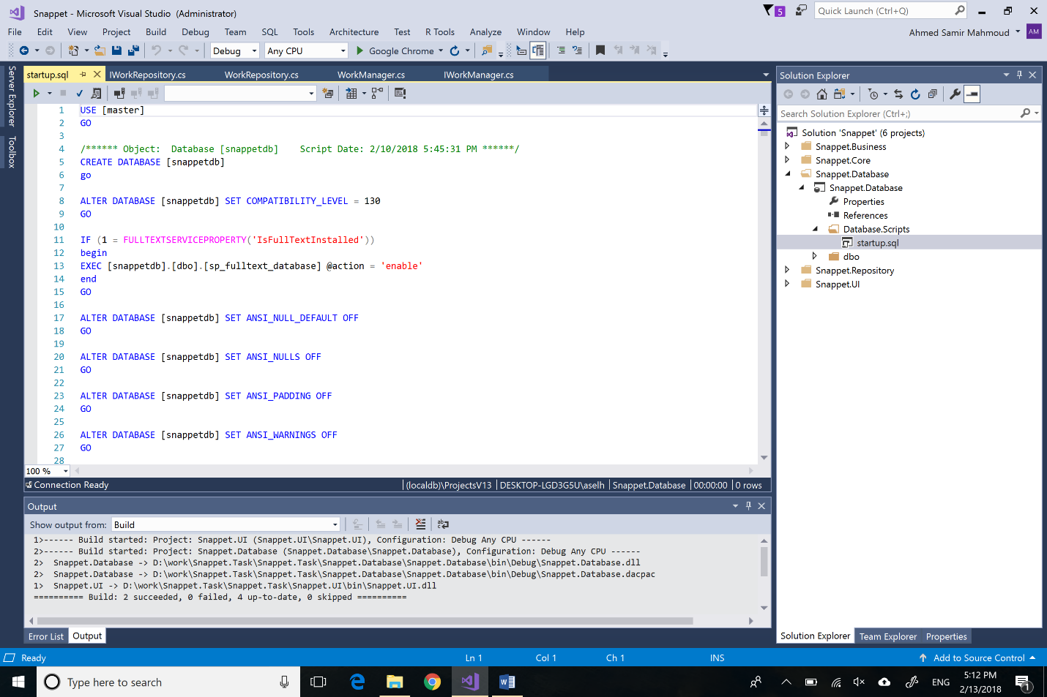Execute script by this Icon  to create database with name “snappetdb”

1. Now your database is up.

## Publish Service To IIS

1. Open IIS.
2. Add new website

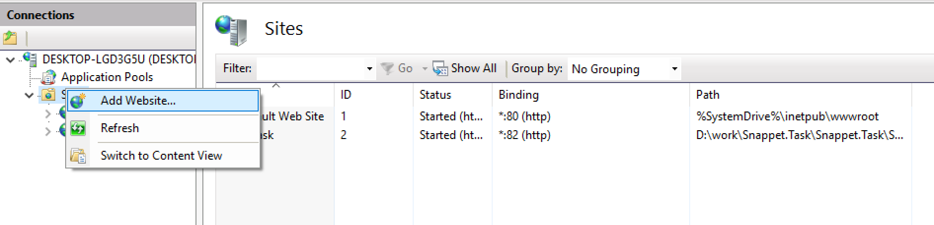

1. 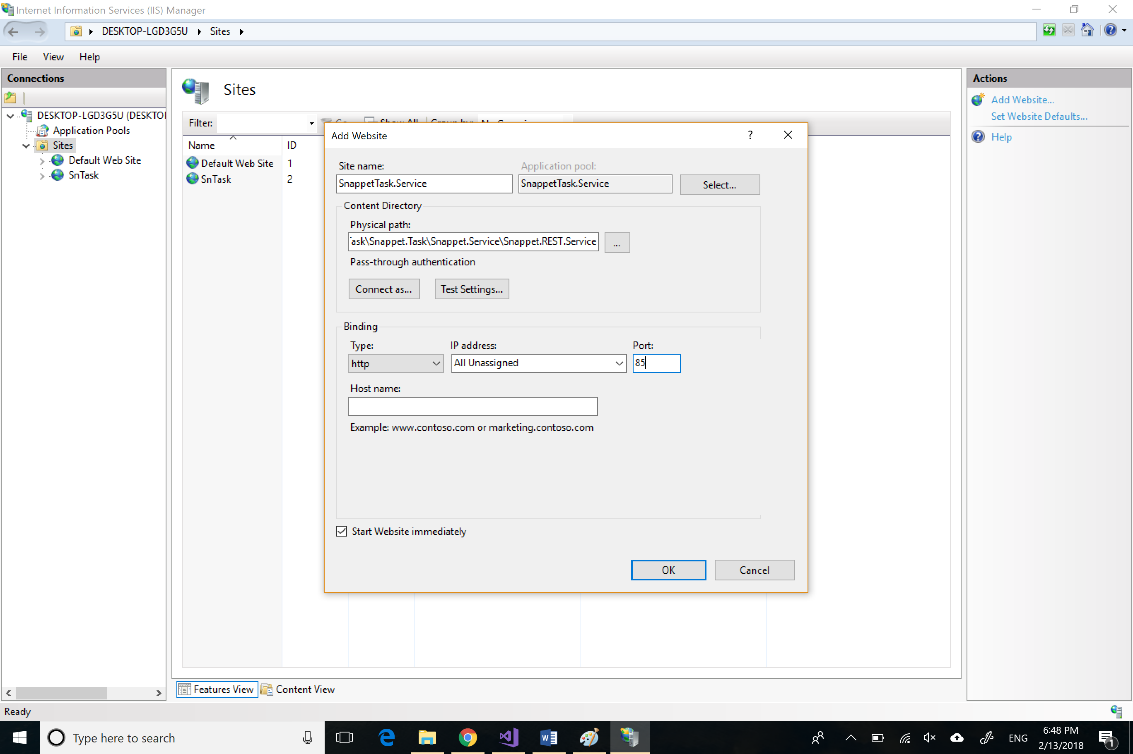Write service name and the physical path of our service

***Physical path will be like “……….Snappet.Task\Snappet.Task\Snappet.Service\Snappet.REST.Service”***

***Please don’t forget to modify the connection string that in web.config file with your sql server data***.

## Publish Website To IIS

1. Open IIS
2. Add new website
3. 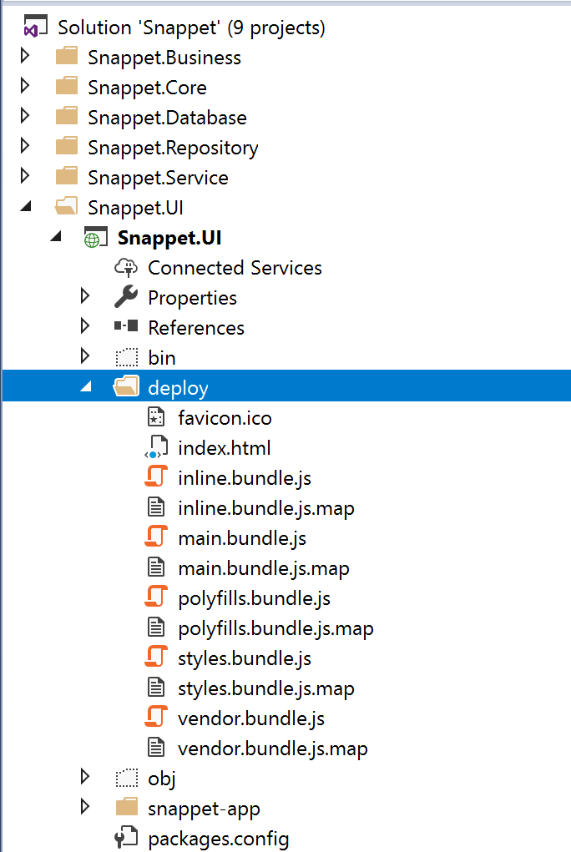Enter SiteName and select “deploy” folder at the root of Snappet.UI project.

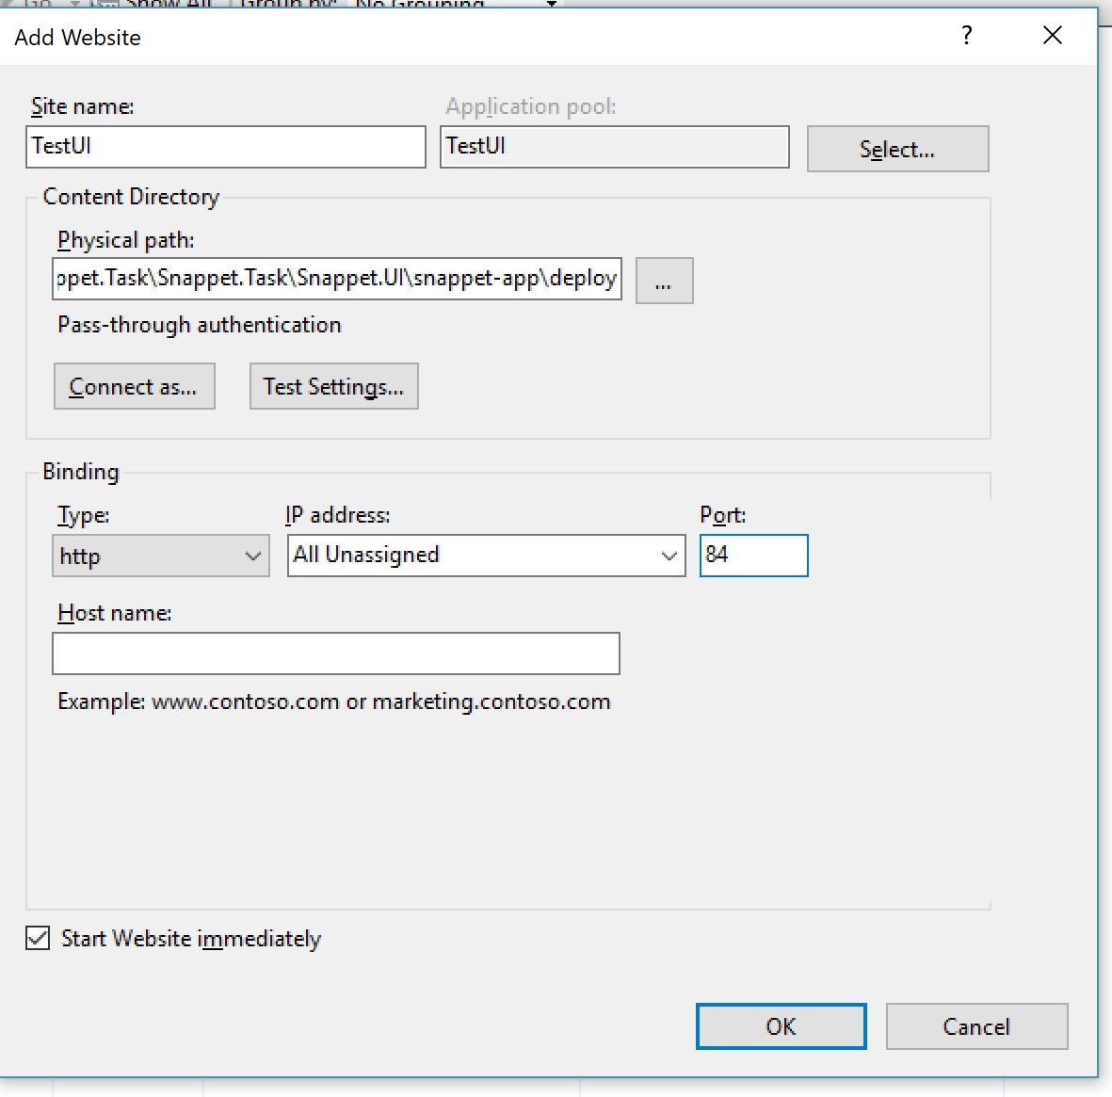***Notes:***

* ***service will be in port 85 and UI in port 84***
* ***The result will be sorted descending progress then descending by difficulty***
* ***The result will be filtered by two conditions:***
  + ***Correct == true***
  + ***SubmitDateTime > ‘2015-03-24 11:30:00 UTC’***